Book Display: Frogs

I do the adult displays at the library where I work each month. I knew I wanted to do a display when I was presented with this assignment. Instead of just doing a mockup I asked the head of the Children’s department if I could do the actual March display. When I presented it to her I had a layout of what I wanted to do. I told her I picked March because she had planned blind date with a book for February, and Easter is in April. Since March is typically St. Patrick’s Day themed, I knew I wanted to do something with an homage but not traditional. I decided on a Spring-like theme with frogs, and they are green! I started putting together what I would like my display to look like. I chose the theme “Hop into spring with a toad-ally good book.” While choosing frog books there was a sub theme emerging that was the life cycle of the frog.
Back in 2009 I got a job teaching extra science lessons to 500 kids in different county schools once a month through a program called P.R.I.D.E. (Personal Responsibility In A Desirable Environment.) One of my lessons was the life cycle of the frog. I had these inflatable props that I would take into the classrooms and thought that would be such a cute thing to add to my display, so off to Amazon I went to look for them. I didn’t find them but what I did find was an acrylic piece containing real preserved stages of the frog’s life cycle. I found a plastic version of my inflatables, so I had to get that as well. I found a puzzle so that the display could be even more interactive, with the life cycle in stages. Also, because I myself am extra I bought rubber duckie frogs, plastic frogs, and teeny tiny frogs, to hide in the teen room. All items are on the display in the pictures, but I will link them bellow. Next, I went to Canva, created my sign, and found a fold out life cycle of the frog activity that I edited to turn into a bookmark craft to put on the display, making it even more enticing and interactive.
Once I got the theme down, I picked a few books for the assignment, and I took pictures of those at first but because it was eventually going to be for the whole month I did have to pull more than 3-4 books, I have added a picture of the excel file of all the books I pulled for this display. The books I picked for the assignment were And the Bullfrogs Sing: A Life Cycle Begins, The Hidden Life of a Toad, How Does a Tadpole Grow?: Life Cycles with The Very Hungry Caterpillar, and A Frog’s Life. I picked them because they all talk about the life cycle of a frog or toad. The review of And the Bullfrogs Sing: A Life Cycle Begins sums up why I used the book with young readers are provided with all the elements necessary to learn about growth cycle, diet, predators, and hibernation (Call, 2019). It is suitable for readers in preschool through second grade so that falls in the ages 6-12 category. I picked The Hidden Life of a Toad based on the subject and cover art. This book was for preschool through third grade students. The book review reveals that it includes a primer on the differences between a frog and a toad, a list of toad facts, and information on conservation efforts. Wechsler also explains how he managed to take the photos—detailed full-color photographs—are everything a budding naturalist could wish for, right down to the warty close-ups (Drucker, 2017). The review does say the writing is kind of dry, but that the pictures make up for it and the facts themselves are interesting. With the book How Does a Tadpole Grow?: Life Cycles with The Very Hungry Caterpillar I realized that it was a stretch to include it in the ages for 6-12 years but even in the review’s verdict the reviewer says most science board books overwhelm or understate. This one is just right (Fakih, 2022). Also keep in mind that for my display I will have tiny tots grabbing from it and it would be nice to have something for them. It is also noteworthy that not every age 6-12 person is on the same reading level and facts are facts. The last book I did a review of was A Frog’s Life. This Kindergarten through third grade book has simple text and detailed illustrations make this is a fun and informative tour through the exciting amphibian world (Phillips, 2018).
I really enjoyed putting this display together, and even though I did review several books in the lower end of the age range you can see from my video and full display picture that I included books for the older kids as well. I even used some of the frogs on my “We Are Lucky To Have Readers Like You” adult book display, where everything from the books to decorations are green!

References:
Call, N. (2019, May 17) [Review of And the Bullfrogs Sing: A Life Cycle Begins, by D. L. Harrison]. https://www.slj.com/review/and-the-bullfrogs-sing-a-life-cycle-begins

Fakih, K.O. (2022, May 27) [Review of How Does a Tadpole Grow?: Life Cycles with The Very Hungry Caterpillar, by E. Carle]. https://www.slj.com/review/how-does-a-tadpole-grow-life-cycles-with-the-very-hungry-caterpillar

Drucker, M. (2017, March 1) [Review of The Hidden Life of a Toad, by D. Wechsler]. https://www.slj.com/review/the-hidden-life-of-a-toad

Phillips, C. (2018, May) [Review of A Frog’s Life, by Borin M]. https://www.slj.com/story/frogs-life-irene-kelly-slj-review

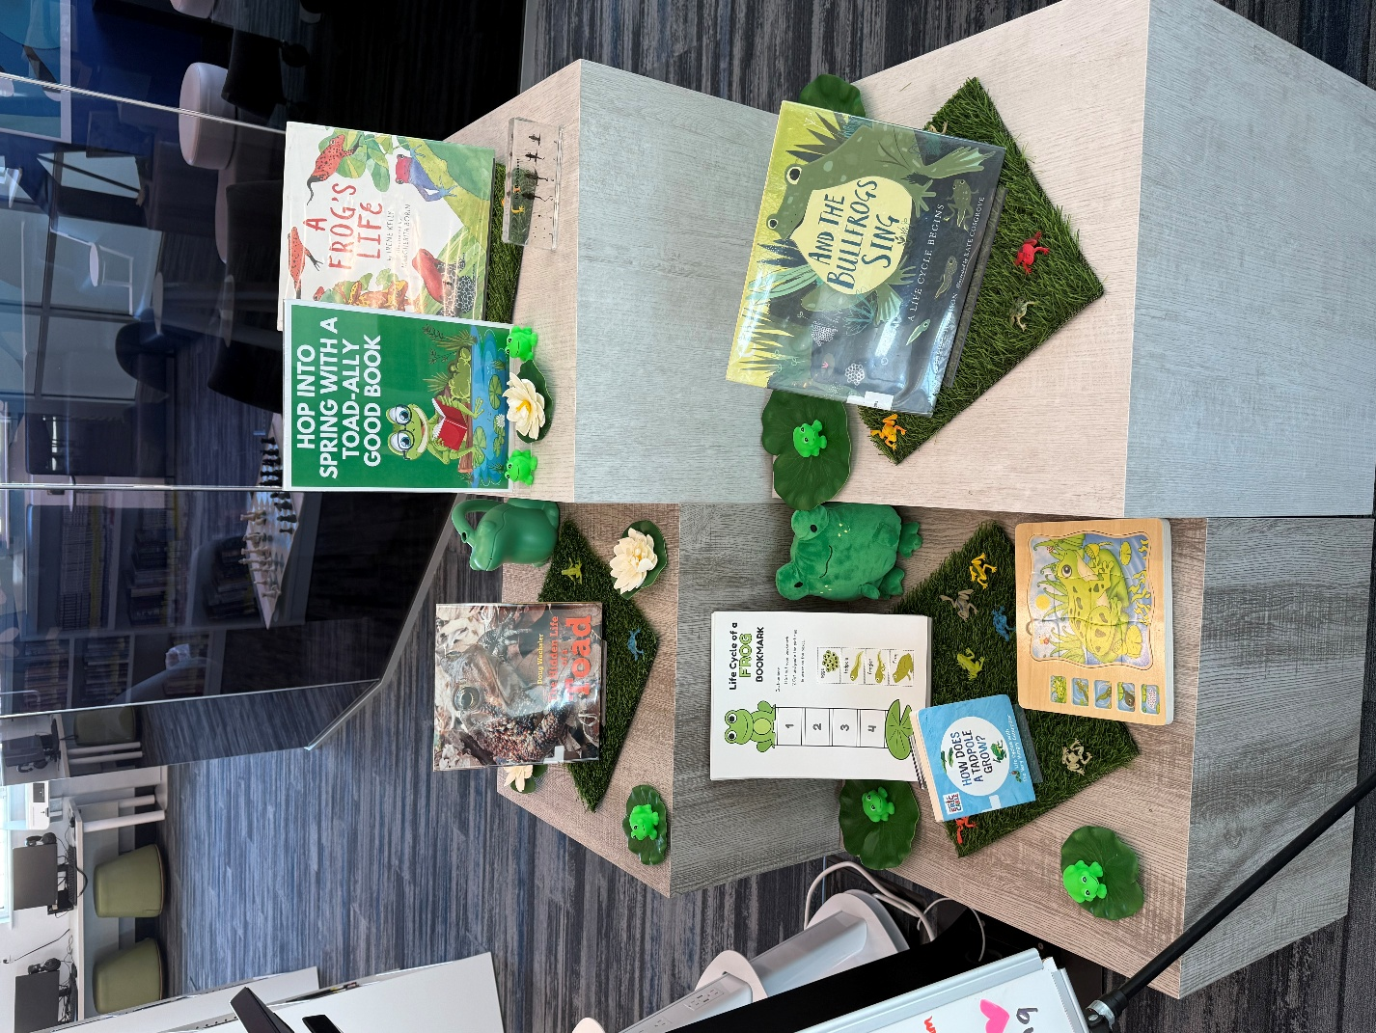

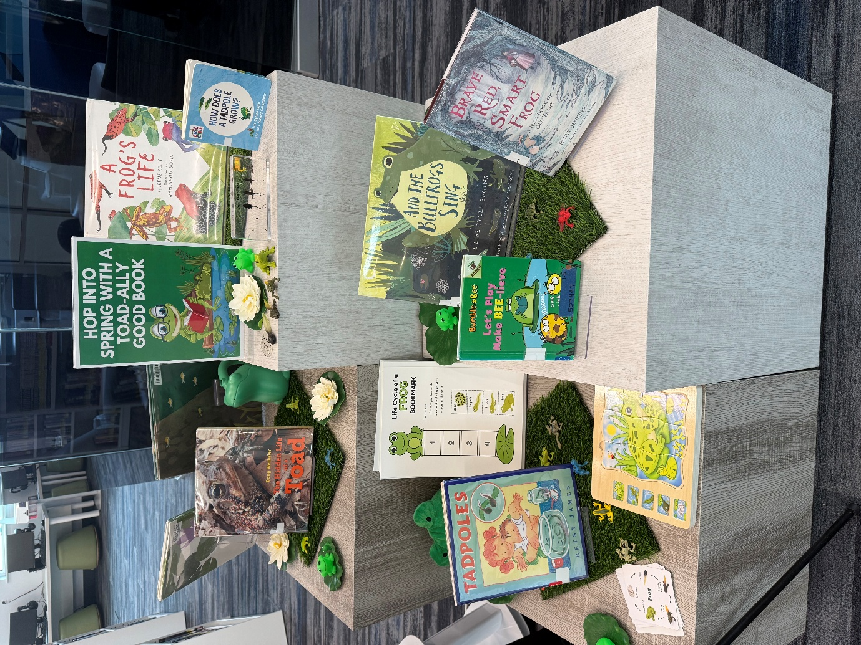

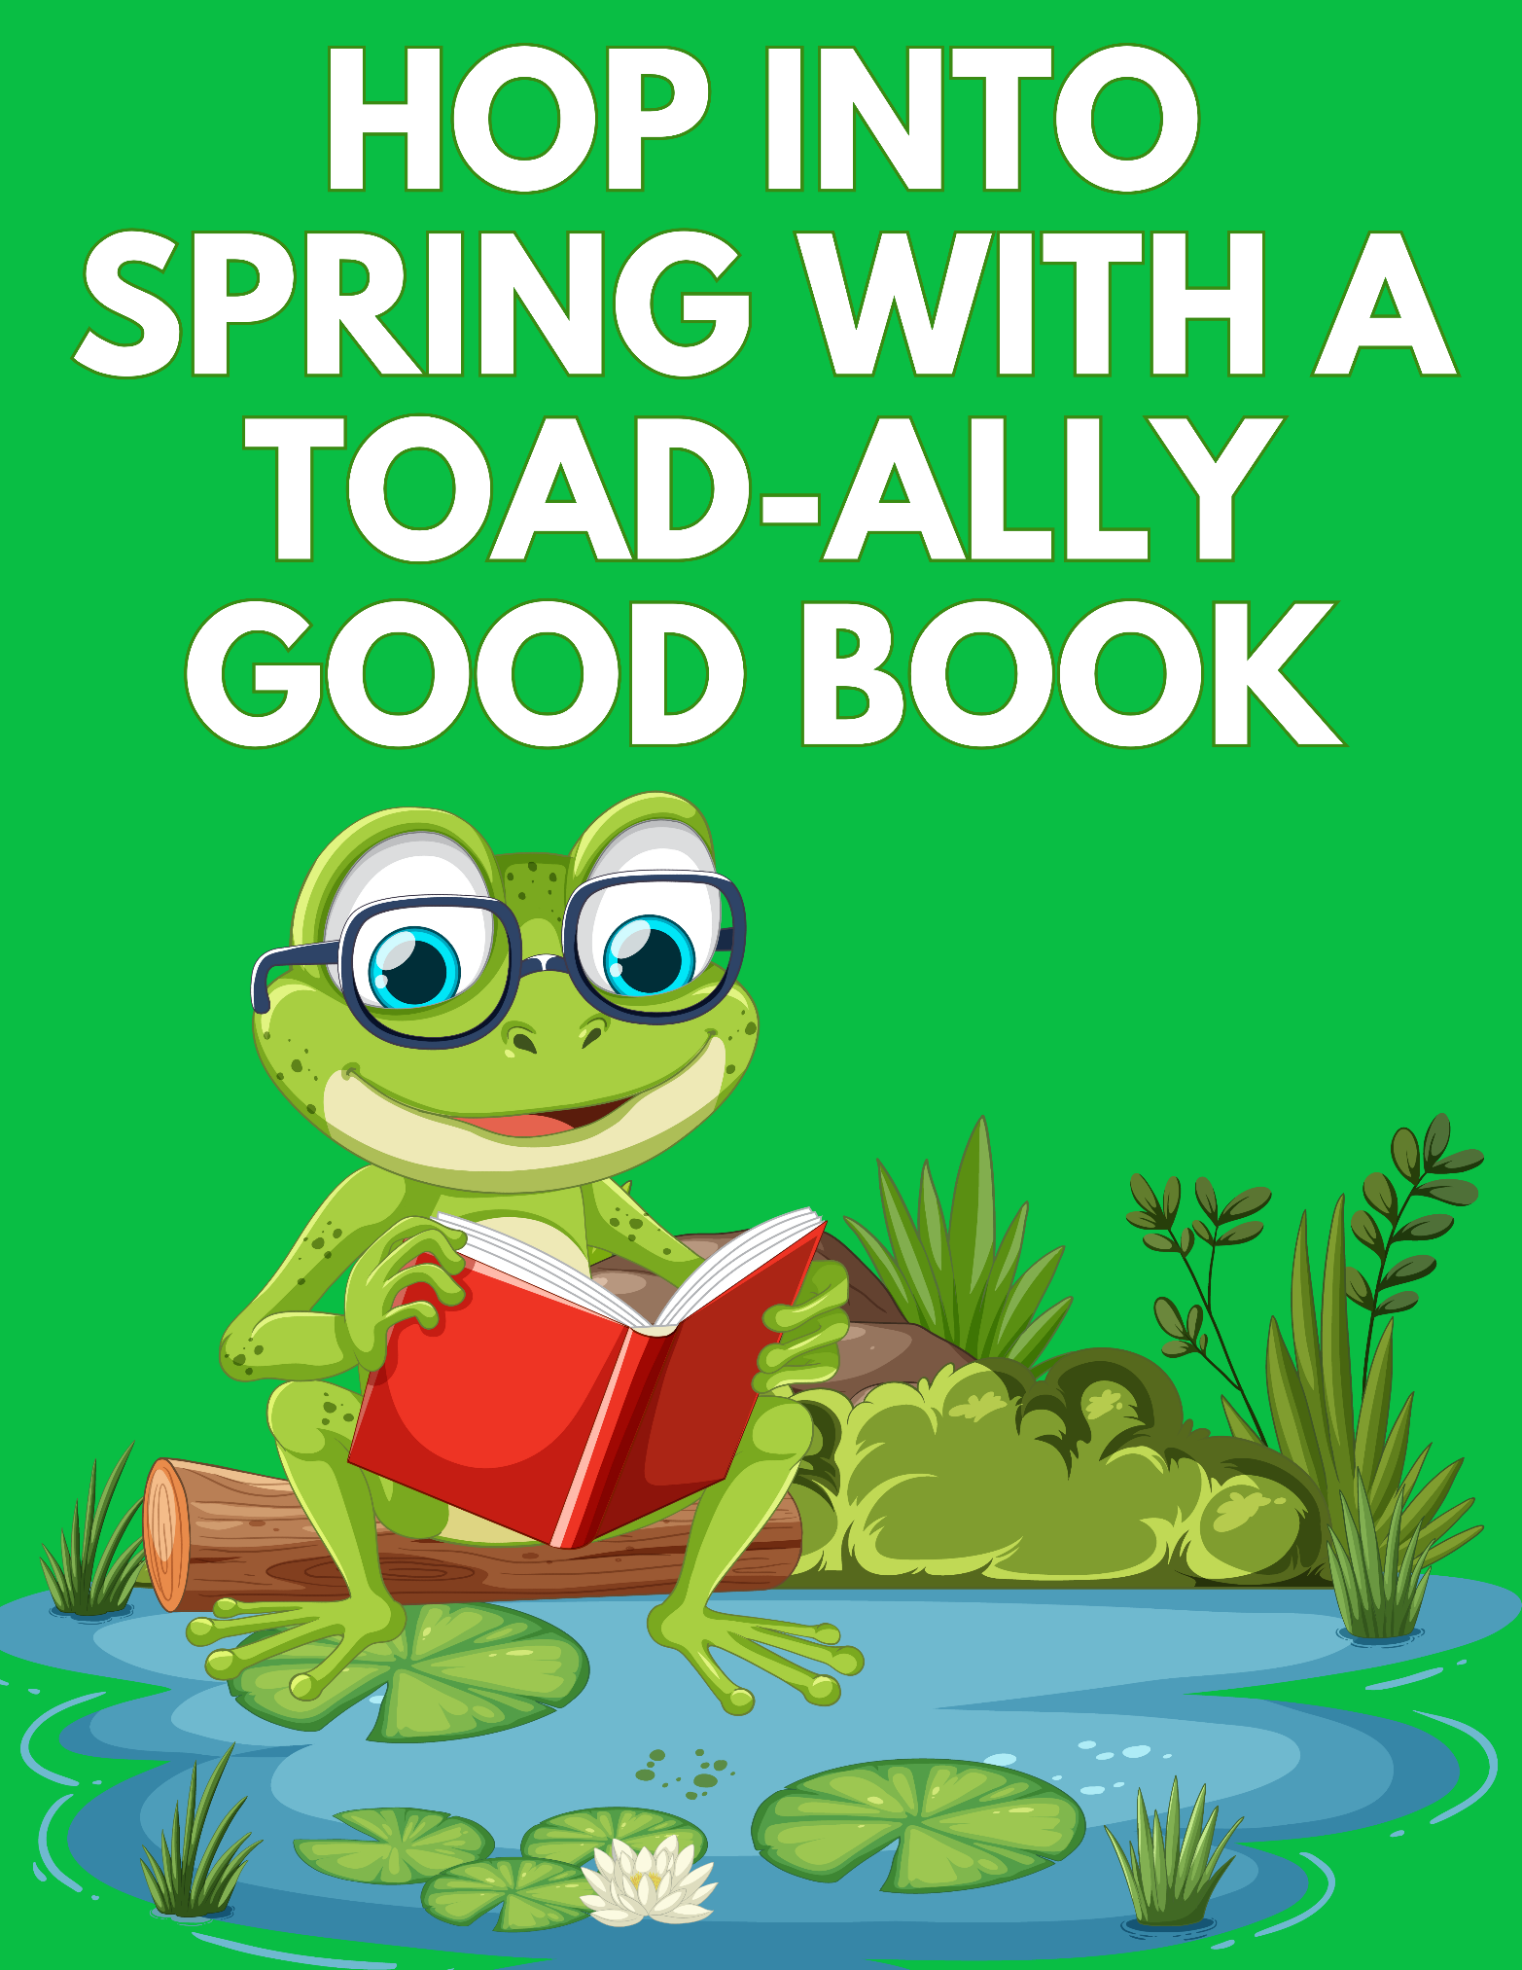
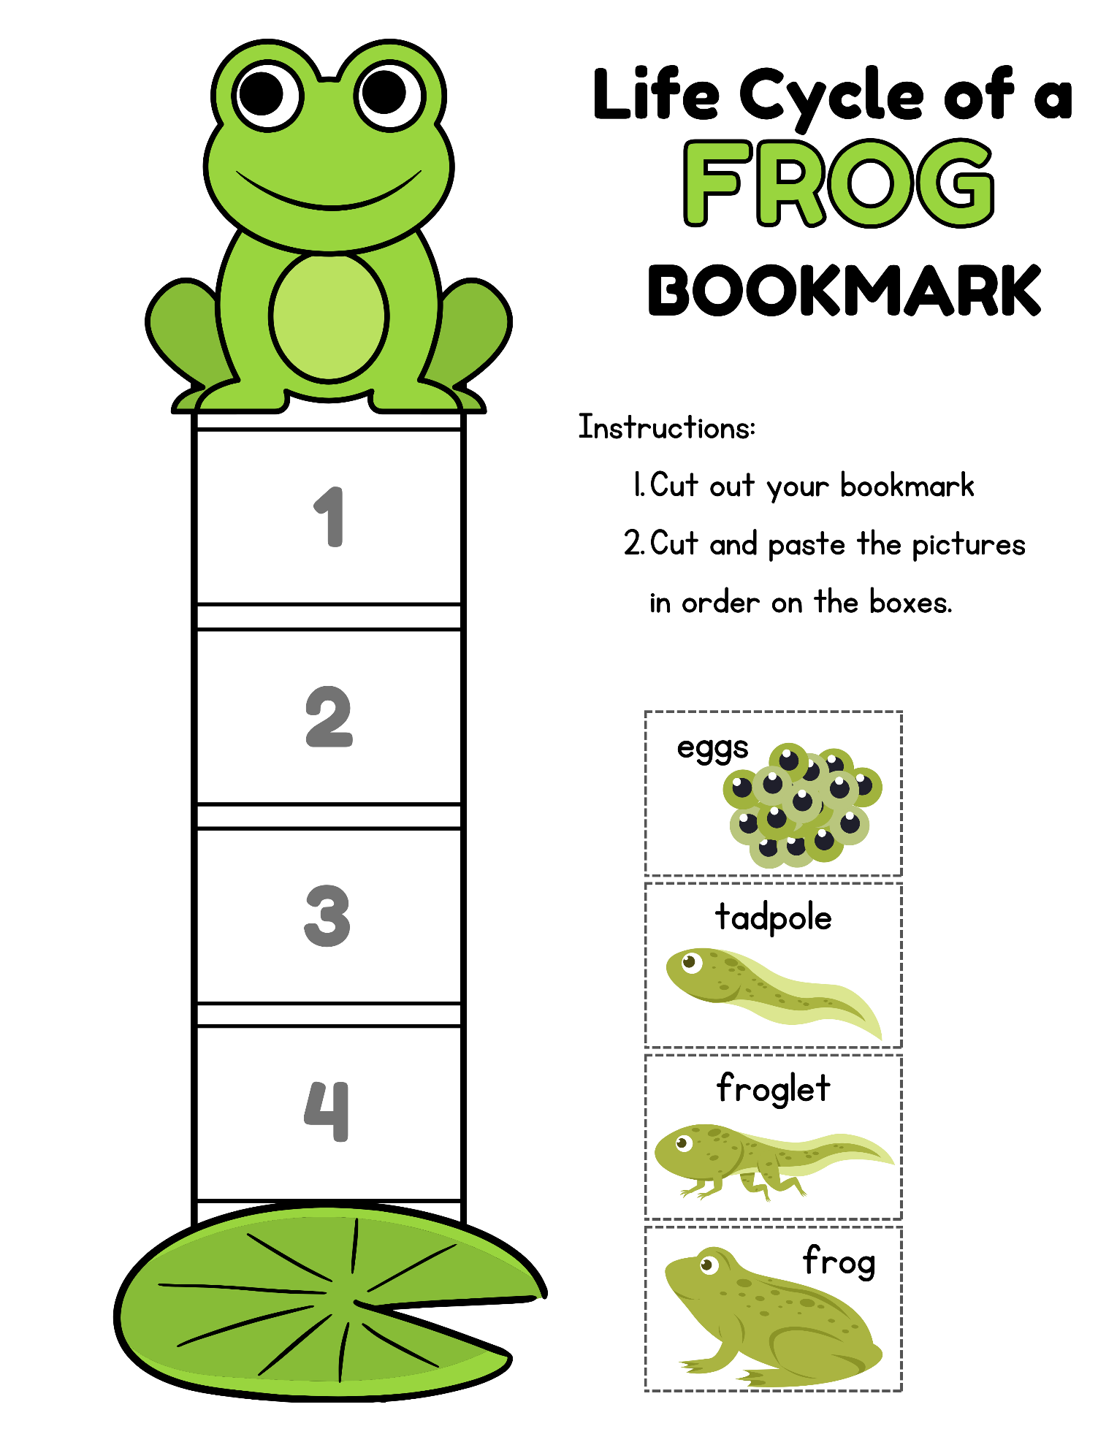
Links to Display Items:
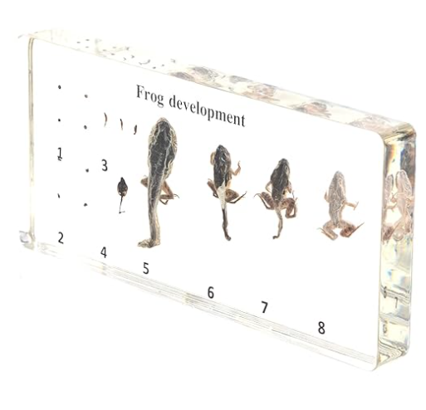 https://a.co/d/4iCqLRD
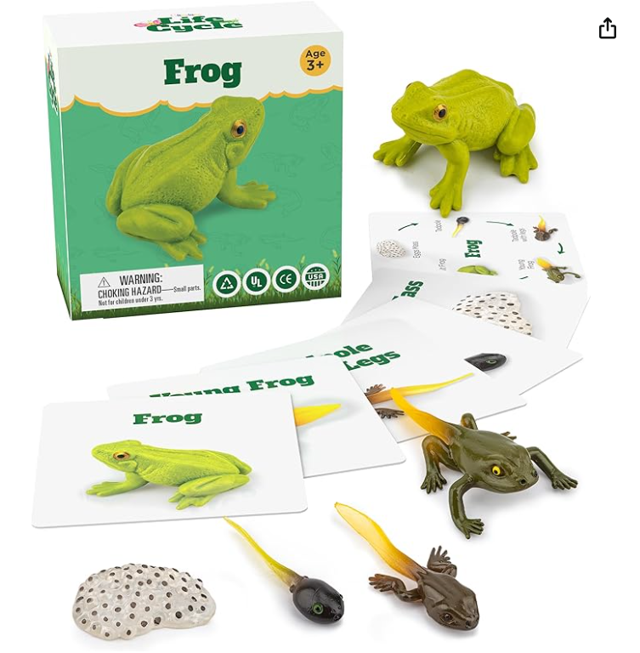 https://a.co/d/0JAqOyr
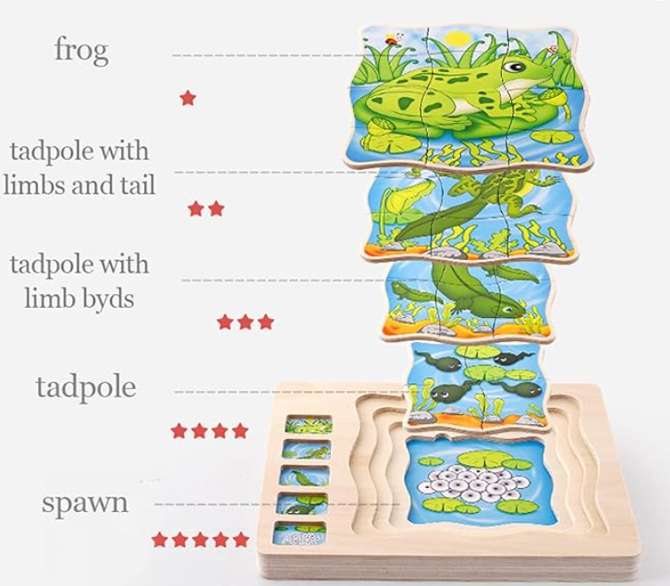 https://a.co/d/6glZCoi
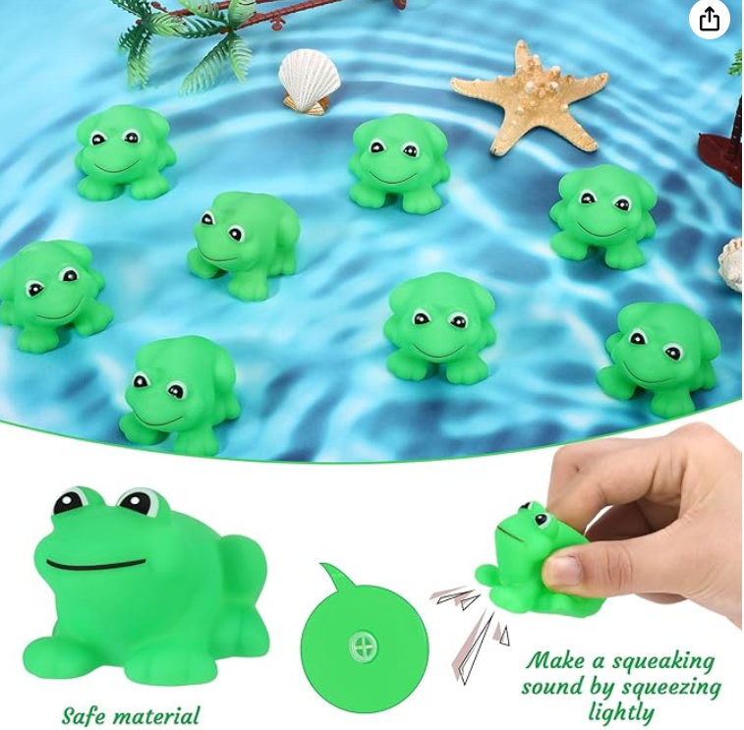 https://a.co/d/5e96s9a
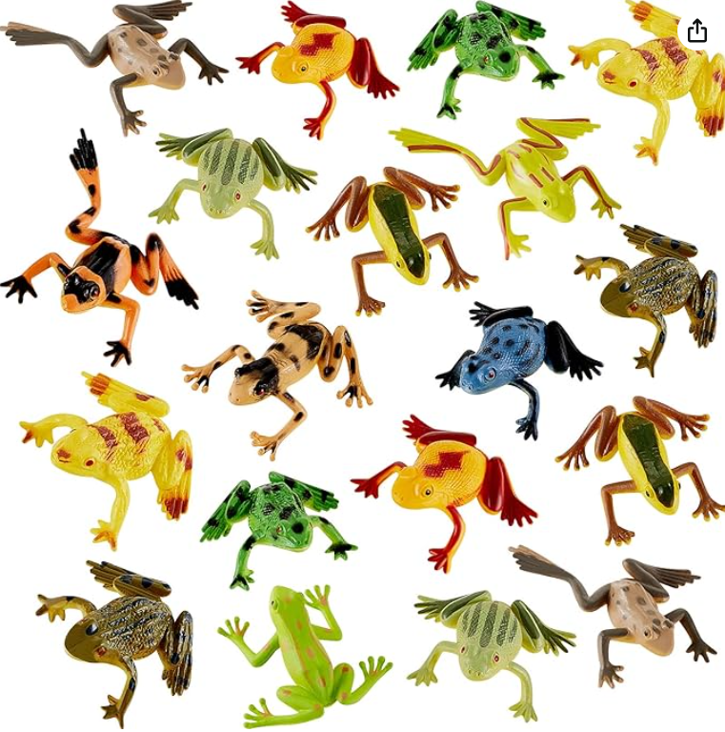 https://a.co/d/dqTdyKr
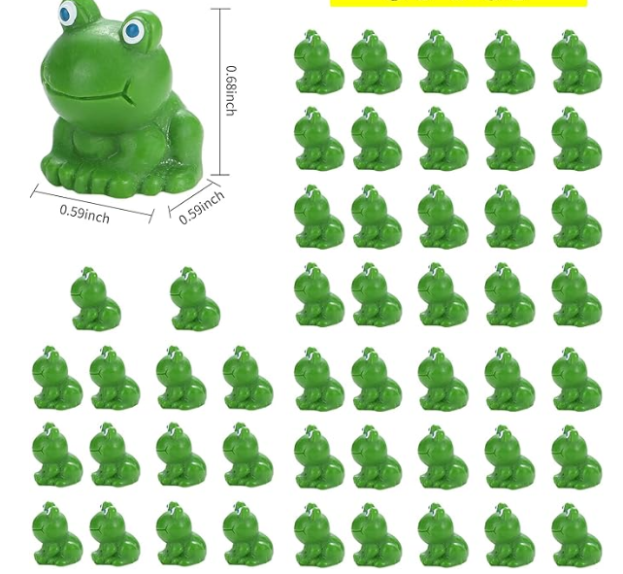 https://a.co/d/iec2wH0

Book Reviews:
And the Bullfrogs Sing: A Life Cycle Begins
by David L. HARRISON
illus. by Kate Cosgrove. 32p. further reading. websites. Holiday House. May 2019. Tr $17.99. ISBN 9780823438341.COPY ISBN
PreS-Gr 2-Starting with a lyrical title, the content illustrates the life cycle of the bullfrog. Young readers are provided with all the elements necessary to learn about growth cycle, diet, predators, and hibernation. Cosgrove's visuals compliment Harrison's text; the pictures and words flow together smoothly and offer an attractive presentation. One element is omitted: the male's role of fertilizing the eggs. Harrison focuses on the female choosing her mate among the full-throated bigger males. End matter consists of fast facts about bullfrogs and recommended books and websites. VERDICT A storytime selection, suitable for the juvenile nonfiction picture book collection.
-Nancy Call, formerly at Santa Cruz Public Libraries, Aptos, CAReviewed by Nancy Call , May 17, 2019

How Does a Tadpole Grow?: Life Cycles with The Very Hungry Caterpillar
by Eric Carle (text) & illus. by Eric Carle
Random. May 2022. 10p. Board $4.99. ISBN 9780593386255.
COPY ISBN
Toddler-PreS–The Very Hungry Caterpillar wants to know how a tadpole grows, and this perfect little board book sets about to explain it in typical Carle fashion: “The eggs are surrounded by a squishy gel. After about two weeks, the eggs are ready to hatch.” The tadpoles, in glowing green translucent tissue paper, seem ready to squiggle off the page, but the text explains how they breathe and then how, two months later, back legs emerge. All of this is fairly exciting stuff, against the crisp white backgrounds that are a hallmark of the series. Front legs, check; lungs, check; tail falls off, frogs!
VERDICT Most science board books overwhelm or understate. This one is just right.
Reviewed by Kimberly Olson Fakih , May 27, 2022

The Hidden Life of a Toad
by Doug WECHSLER
photos by Doug Wechsler. 48p. eBook available. further reading. glossary. websites. Charlesbridge. Mar. 2017. Tr $17.99. ISBN 9781580897389.
COPY ISBN
K-Gr 3—Biologist and photographer Wechsler's chronicle of a toad's journey from embryo all the way to adulthood is insightful. The images—detailed full-color photographs—are everything a budding naturalist could wish for, right down to the warty close-ups. The text, while clearly written and full of intriguing tidbits (for instance, a tadpole hangs out in water too shallow for hungry fish, and the tadpole's tail is recycled within its body) does lack a certain grace. Still, the content presented is pertinent to the life cycle of amphibians. The book includes a primer on the differences between a frog and a toad, a list of toad facts, and information on conservation efforts. Wechsler also explains how he managed to take the photos.
VERDICT Suitable for libraries needing to bolster their early nonfiction collections.
Reviewed by Marie Drucker, Hewlett-Woodmere Public Library, NY , Mar 01, 2017

A Frog’s Life
redstarKELLY, Irene. A Frog’s Life. illus. by Margherita Borin. 40p. Holiday House. May 2018. Tr $17.99. ISBN 9780823426010.
K-Gr 3 –Kelly, winner of numerous awards for her nature books for children, now introduces the amazing activities that encompass the life of a frog. This picture book uses simple, informative text and detailed illustrations to introduce the many varieties of frog species and their life cycles. (“Baby frogs called tadpoles…emerge with gills to help them breathe in water and tails to help them swim.”) This incredible metamorphosis is illustrated in detail as a tadpole loses its fishy tail and gills and becomes a frog. Kelly peppers the text with unusual facts and bits of scientific trivia (“the golden poison frog is only as big as a paper clip, but the toxin it carries can kill 20,000 mice or 10 people”). Borin has perfectly captured the lives of frogs and their various habitats by creating attractive watercolor illustrations in a design that is reminiscent of an artist’s sketchbook. The detailed drawings will encourage students to look closely as they discover different patterns and textures. Each picture shows a particular species, which Kelly carefully names even as she describes common behaviors. Also included is current information on frog disappearances and conservation efforts to save endangered ones. The simple text and detailed illustrations make this is a fun and informative tour through the exciting amphibian world. VERDICT Perfect for young researchers and a welcome addition to all libraries.–Carole Phillips, Greenacres Elementary School, Scarsdale, NY This review was published in the School Library Journal May 2018 issue.
Books Held and Put on Display Status for the Month of March:
